Did you read the interesting facts when you found Nukie?
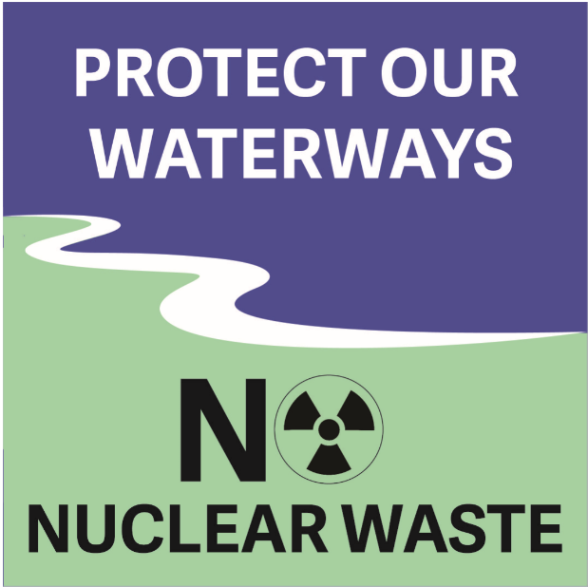
Use the information from those quick facts to fill in the blanks below.
Send your completed page to nodgrsouthbruce@gmail.com or mail to Box 147 Teeswater, Ont. N0G 2S0 for a wee Nukie surprise!
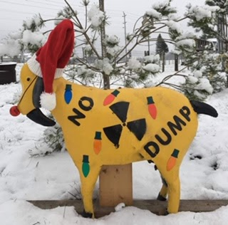

Currently, there are no operating high-level nuclear waste deep geological repositories (DGR). The only currently operating DGR, for low/intermediate waste is located in the middle of a _____________ in ___ __________. Nobody lives near it and the nearest town is _____km away. High-level nuclear waste has never been stored ____________ in a designated repository before. This proposed DGR is an ____________.
Uranium is used to power nuclear reactors. When the _____________ no longer makes enough energy, a very dangerous, high-level waste, called __________ _________ remains. After uranium is used in the reactor, to produce energy, it gives off unseen particles called _______________, which can make you sick. That is why the high-level waste has to be stored, in sealed containers, for hundreds of ____________ of years. It takes that long to cool down and reduce the radioactivity to safe levels.
In order for the high-level waste to be placed in a DGR it needs to be _____________ at the new site. The ____ _____ process used to do this is unproven technology, another experiment.
Radioactivity is a form of ________ that cannot be shut off. Nuclear __________ remains dangerous for __________ of thousands of years. The cost to produce ___________ energy keeps rising while _____________ energy costs are getting lower.
The choices we make today will affect our future generations,
our health and our environment.

Name/s________________________________
Address_________________________________________________
Email address_______________________
Phone___________________

